Sesi 13 - Advanced Mobile Testing with Appium
Nama: Janji Nur Subekti

ScreenShot - passed
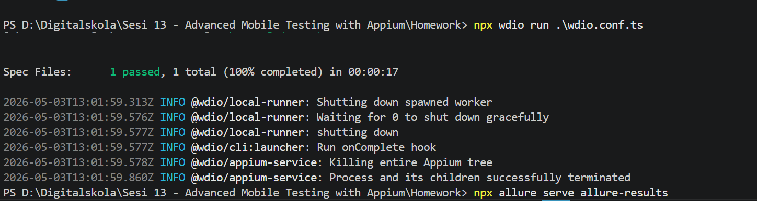

ScreenShot - report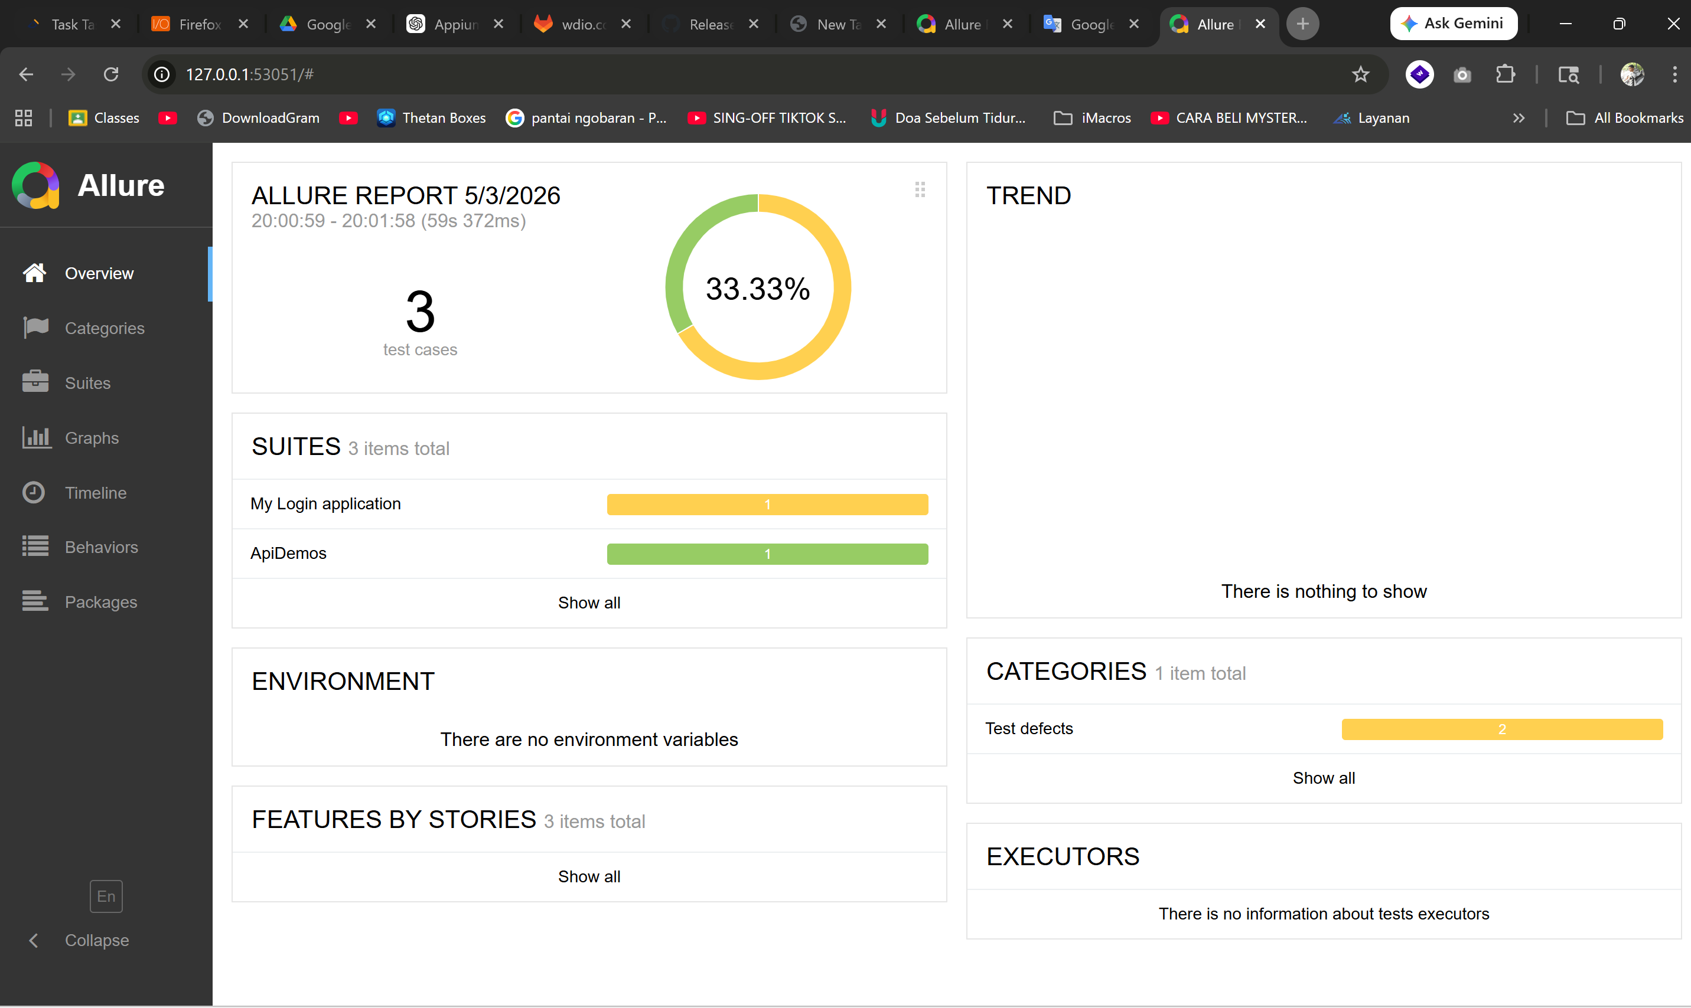
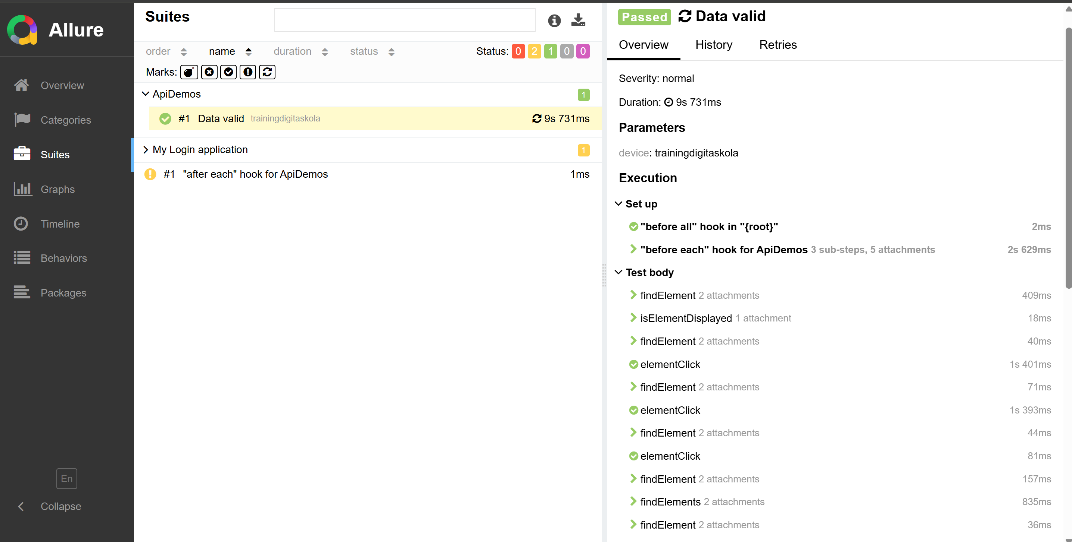

Link
Link code : https://github.com/jans456/Dgitaskola/tree/main/Sesi%2013%20-%20Advanced%20Mobile%20Testing%20with%20Appium/Homework

